Q 1) What is Your Understanding of Blockchain?

Ans: Block chain is a mix of Technology Distributed & Cryptography where information is :
.Verifiable
.Unchangeable
.Tamper-proof
.Immutable

> It contains immutable,tamper-resistant, and permanent records.
once a record has been added to the chain it is very difficult to change.

Q 2.) What is the core problem blockchain trying to solve?

Ans: .
➢ Data Authentication
➢ Data Integrity
➢ Security
➢ Decentralization System
➢ Trust issue
➢ Hacking

10 Problems that Blockchain Technology Solves:

- Supply Chains and Item Histories
- Voting
- Government Operations
- Intellectual Property
- Marijuana Industry’s Banking and Logistics Issues
- Cloud Storage
- Charity
- Real Estate
- Crowdfunding
- Currency and Transaction Support

Q 3) What are The few feature which Blockchain will give you

Ans: -a)Verifiable.
b)Unchangeable.
c)Tamper proof.
d)Immutable.
e)Transparent.
f)Decentralized.

4) What are the all things
Blockchain contain?

➢ Previous Block’s Hash Key
➢ Data or Record
➢ Block No
➢ Mining key
Blockchain cantains the fingure print of previous Block , dataset of own block and fingure print of own block .

Previous Fingureprint + new Doc = Current Fingureprint

A + B = C
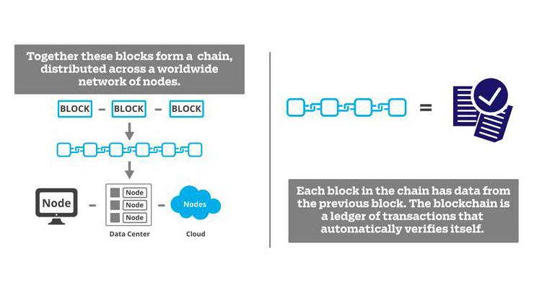
C + D =E
Where B and D are the Dataset.

Q 5) How is the verifiability of Blockchain is been attained?

Ans: It works on the system of fingureprint .
Each Block Has its own unique signature,which is stored in the next block.

.Every block contains the previous block’s hash and own block’s hash and because of that we can create the chain of block and link the every block to whole chain. This hash gives the digital signature of block and it is same for the other who are connected This hash gives the digital signature of block and it is same for the other who are connected with the network. Because of the digital signature we can verify the blockchain.

